SC2011B EXE #3 Evaluation form

Students’ initials | Instructions | Code documentation | execution | Results | Visualization | grade
TA | Not submitted |  |  |  |  | 0
EZ | OK | Some comments in the code | C + Condor  Why did you write in the condor submit file: input = /dev/null ?? you could simply ignore the input  Random seed based on time and process id | Although you did a fit using polyfit there is no discussion about the fit quality and the expected value.  The outputs were not enclosed | OK, with python | 85
EN | ok | Some comments in the code | C (gcc) + condor | Fitting the data with an exponent. OK  The outputs were not enclosed | How and which tools did you use for the fitting and the plot | 90
BK | ok | Comments in the code | VC++ + Condor  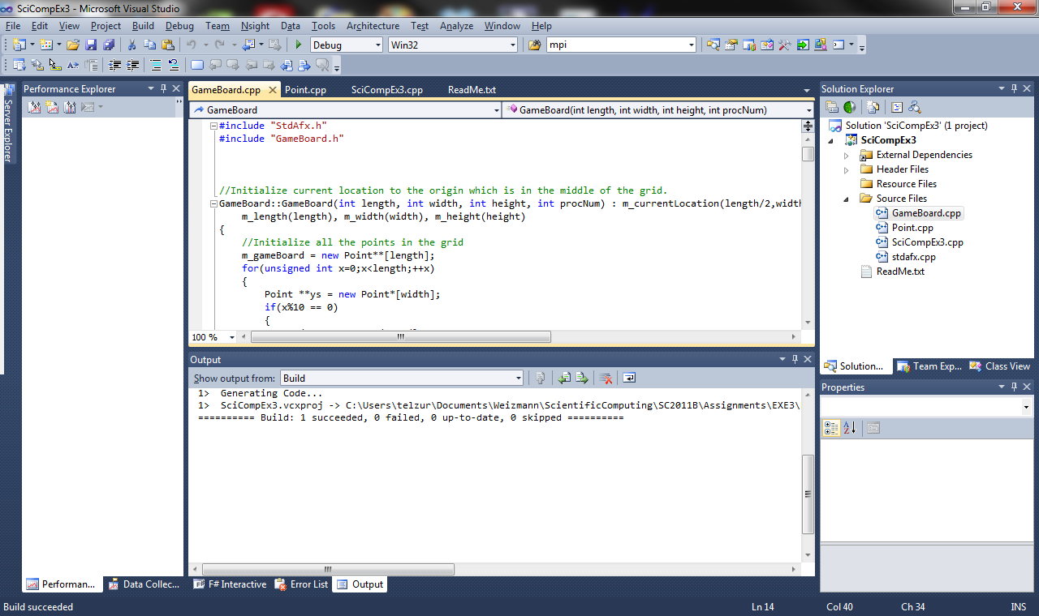  I couldn’t check the execution due to a crash:  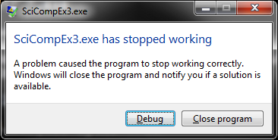 | Fit - OK  The condor submit file, SciCompEx3.sub  , is missing!! | Vis. In Excel. | 90
FH | no | some | Matlab + condor  Wrong usage of condor. You cannot submit a matlab script as the executable. The executable should be matlab itself. The scrip should be specified in the submit file as an argument. You could use a “wrapper” file (you will have to read about that in the internet). | No results, No fitting.  Plot tite”3D…” but you are showing a 2D case. | none | 70
NT | OK |  | Python+condor  I could not execute the code because of the following error:  IOError: [Errno 2] No such file or directory: 'resources/random_walk_pickle_rms_0' | Is the fitted ν close the the expected one? | Using python (pylab) | 85
EG | Didn’t submit assignments |  |  |  |  | 0

