SC2011B EXE #1 Evaluation form

Students’ initials | Instructions | Code documentation | execution | Results | Visualization | grade
TA | Ok | Ok  Code in Python | Evaluate Lavyan.dat  Main()  File "C:\Program Files (x86)\Wing IDE 101 4.0\src\debug\tserver\_sandbox.py", line 82, in main  ValueError: invalid literal for int() with base 10: '1.'  >>> main()  Moon inclination:  0  Integration Step:  1  Time to calculate:  100  Write Every __ Steps:  10  OK | Not the right plots. Instructions and code to generate plots are missing. Output to ‘sat.dat’ | Not included | 90
EZ | Ok | Code on “C”  Report - Very good | make clean;make  OK | Good plots.  Titles on axes are missing. | In python | 95
EN | Ok  No y- axes titles in the plots. | Code in Python | Python hw1.py  OK | ok | Matplotlib script  OK | 90
BK | Readme.txt | Vc++ | Exe file runs well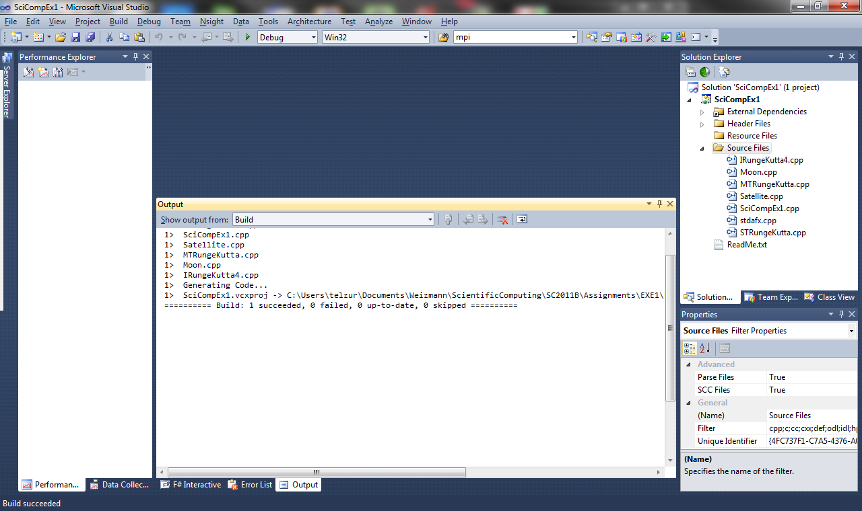 | Into text file.  Wrong plots  No titles in the plots | No instruction or scripts for generating the plots | 90
FH | None. | Matlab, c++  Documentation only in the code | Matlab version: no Runge-Kutta  “Enter the initial orbit period (T/Ts) in seconds” *** this ration cannot be in seconds. It is dimensionless  “Enter frequency” – this is not clear. What do you mean? | No outputs from the C++ version | No plot generation scripts There are plotting commands in the matlab code. No plots were attached | 65
NT | 17 pages | python | Give me t_mult (T_s * t_mult = t_max): 10  Give me N_w (graph interval) : 10  --- Runge Kutta in work  --- Iteration 155095 / 861640  --- Iteration 327423 / 861640  --- Iteration 499751 / 861640  --- Iteration 672079 / 861640  --- Iteration 844407 / 861640  --- Moving to polar  --- Producing graphs  --- Bye bye  >>>  ok | Some plot look suspicious.  No axes titles | Built in the code with matplotlib | 90
EG | Nothing was submitted |  |  |  |  | 0

